For each of the problems be sure to identify each of the steps discussed in the problem-solving lesson.

1. Define the problem
   1. Do this in *your own words*.
   2. What insight can you offer into the problem that is not immediately visible from the word problem alone?
   3. What is the overall goal?
2. Break them apart
   1. What are the constraints?
   2. What are the sub-goals?
3. Identify potential solutions
   1. For each of the sub-problems you’ve discussed in #2, what is a possible solution?
4. Evaluate potential Solution
   1. Does each solution meet the goals?
   2. Will each solution work for ALL cases?
5. Choose a solution and develop a plan to implement it
   1. Explain the solution in full.
   2. Describe some test cases you tried out to make sure it works. (You can include drawings and diagrams as part of your explanation as long as they are clearly communication the solution).

Problems:

A Cat, a Parrot, and a Bag of Seed:

A man finds himself on a riverbank with a cat, a parrot and a bag of seed. He needs to transport all three to the other side of the river in his boat. However, the boat has room for only the man himself and one other item (either the cat, parrot or seed). In his absence, the cat could eat the parrot, and the parrot would eat the bag of seed. Show how he can get all the passengers to the other side, without leaving the wrong ones alone together.

1. Define the problem
   1. The problem here is the man has a boat that will only fit him and 1 item/animal. If he leaves the parrot and the cat to bring the seed first the cat will eat the parrot. If he leaves the parrot and the seed to bring the cat over first the parrot will eat the seed.
   2. An insight that is not immediately visible in the problem is if he brings the parrot first and then goes back to get either the cat or the seed, he will have the same problem when he leaves the drop off side to go back and get the last item/animal.
   3. The overall goal is to get the get the parrot, the cat and the seed over to the other side without the parrot eating the seed or the cat eating the parrot.
2. Break them apart
   1. The constraints are that if you leave the parrot alone with the bag of seed, the parrot will eat the seed. If you leave the cat alone with the parrot, the cat will possibly eat the parrot.
   2. Sub-goals?
      1. Get the parrot on the other side without being eaten on either side
      2. Get the bag of seed on the other side without being eaten on either side
      3. Get the cat on the other side without eating the parrot on either side
3. Identify potential solutions
   1. Solutions to sub-goals
      1. Bring parrot over first
      2. Bring the bag of seed over second and bring the parrot back to the other side
      3. Bring cat over and then go back and get the parrot.
4. Evaluate potential Solution
   1. Each solution meets the goals.
   2. Each solution works for all cases.
5. Choose a solution and develop a plan to implement it
   1. The man can bring the parrot over first and then go back to get the bag of seed. The man then can drop the bag of seed off and bring the parrot back over to the first side. Then he will drop the parrot off on the first side and bring the cat over to the other side. Lastly he will go back and get the parrot and all 4 of them will be on the 2nd side.
   2. I strategized in my head about how I can solve this problem. At first, I thought the man could put the parrot on his shoulder and bring the bag of seed over in the boat, drop the seed off and when the parrot still on his shoulder he could then bring the cat. Thinking while watching the bag of seed the parrot wont eat it and by watching the cat, the cat won’t eat the parrot. Then I realized that we do not know how big these animals are and how big the bag of seed it. The parrot could be too large to fit on the man’s shoulder. I knew I was close to solving. That is when I thought what if the man could bring the parrot over first. The he could go back and get the bag of seed. When he drops off the seed he brings the parrot back with him. I continued throughout the problem and finally I realized I was finished. The problem was solved.

Socks in the Dark:

1. There are 20 socks in a drawer: 5 pairs of black socks, 3 pairs of brown and 2 pairs of white. You select the socks in the dark and can check them only after a selection has been made. What is the smallest number of socks you need to select to guarantee getting the following:
2. At least one matching pair.

i. 4

1. At least one matching pair of each color.

i. 10

1. Define the problem
   1. The problem is that you have 20 total pairs of socks. 5 pairs are black, 3 pairs are brown and 2 pairs are white. You need to select the smallest number of socks in the dark to get at least 1 matching pair and at least 1 matching pair of each color.
   2. Some insight is that there are 10 total socks that are black, 6 total socks that are brown and there are 4 total socks that are white.
   3. The goal is that you need you choose the smallest number of socks to get at least 1 matching pair and at least 1 matching pair of each color.
2. Break them apart
   1. The biggest constraint is that you are selecting these socks in the dark
   2. Sub Goals
      1. Selecting the smallest amount of socks to get at least 1 matching pair.
      2. Selecting the smallest amount of socks to get at least 1 matching pair of each color.
3. Identify potential solutions
   1. Solutions to sub goals
      1. Break down the pairs of socks by pairs and colors, and how many socks in each pair. From there figure out the probability of selecting the right amount of socks for each sub goal.
4. Evaluate potential Solution
   1. The solution meets goals
   2. The solution works for all cases.
5. Choose a solution and develop a plan to implement it
   1. You fist need to break down the problem into different parts. Write down how many pairs if socks are there in each color. The write down how many socks are there total in total. Since there are 3 colors total, you need to select at least 4 socks to get at least 1 matching color. Next you need to think about how many socks you need to select in order to have at least 1 matching pair of each color. This one is a bit harder to figure out. I chose 12.
   2. I broke down the problem on a piece of paper. In my mind I did the rest.

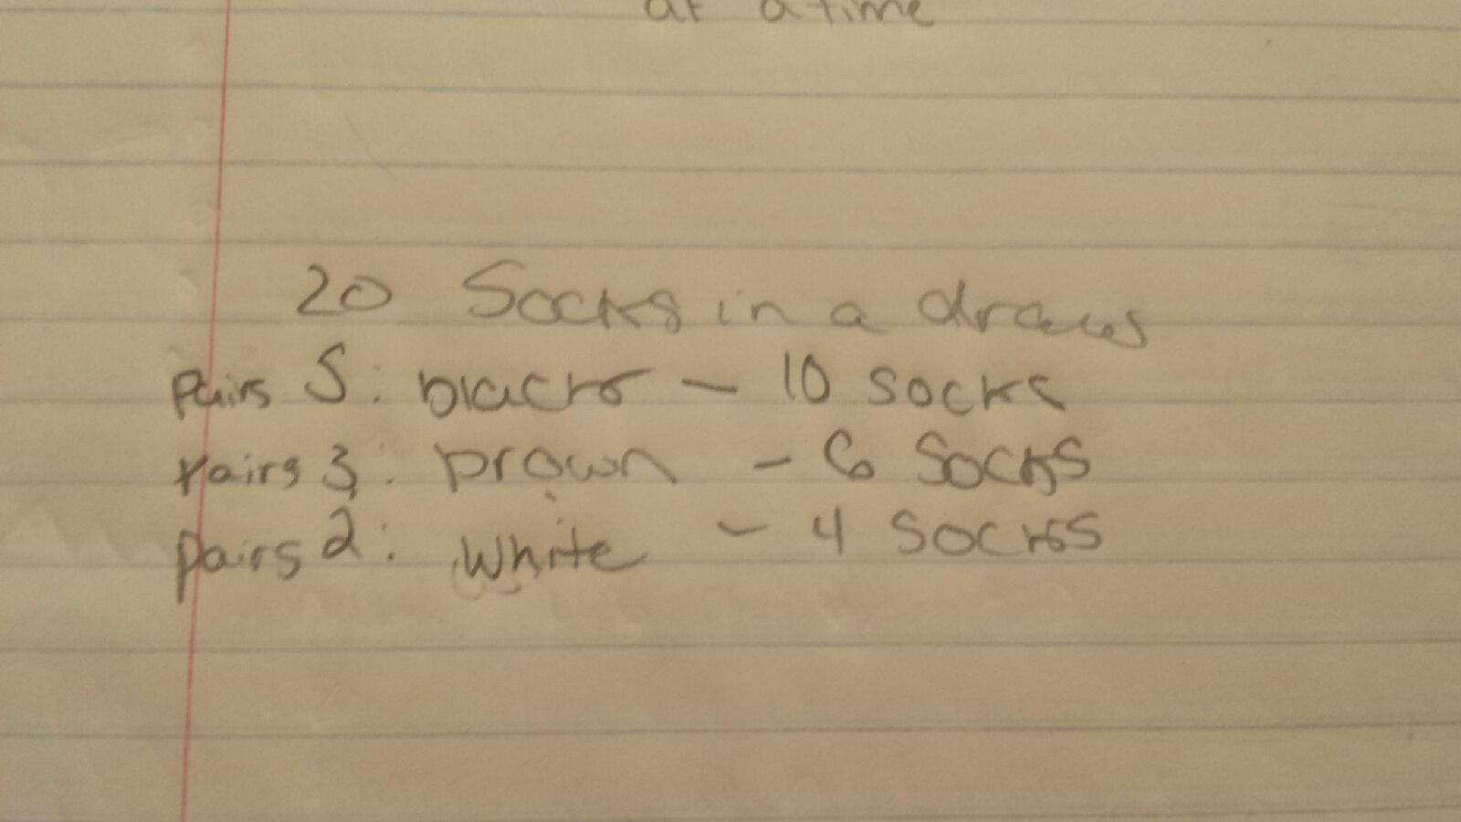

Predicting Fingers:

A little girl counts using the fingers of her left hand as follows: She starts by calling her thumb 1, the first finger 2, middle finder 3, ring finger 4, and little finger 5. Then she reverses direction, calling the ring finger 6, middle finger 7, first finger 8 and thumb 9, after which she calls her first finger 10 and so on. If she continues to count in this manner, on which finger will she stop?

1. What if the girl counts from 1 to 10
   * 1. First finger
2. What if the girl counts from 1 to 100
   * 1. Ring finger
3. What if the girl counts from 1 to 1000
   * 1. First Finger
4. Define the problem.
   1. The problem is the little girl is counting on her finger a certain way. She counts from 1 starting with her thumb finger and when she gets to six she is on her ring finger. We have to figure out what finger she will land on if she counts to 10, 100 and 1000 all starting from the number one and starting with her thumb finger.
   2. After starting the counting I noticed all even numbers were on the ring and first finger.
   3. The overall goal is to figure out what finger the little girl will land one when she counts from 1 to 10, 1 to 100, and 1 to 1000.
5. Break them apart
   1. You cannot count on 2 hands. You have to start with your thumb. When you get to number 6 you have to go backwards and count 6 on your ring finger and continue counting in that manner.
   2. Sub Goals
      1. Count from 1 to 10 starting with your thumb. You should land on your ring finger for number six.
      2. Count from 10 to 100 making 11 your middle finger.
      3. Count from 100 to 1000 making 101 your pinky finger.
6. Identify potential solutions
   1. Solutions
      1. If you continue on this path you will land on your first finger for number 10.
      2. If you continue on this path you will land on your ringer finger for number 100
      3. If you continue on this path you will notice that number 200 is on your first finger. You can continue counting in hundreds using your first and ring fingers making 300 your ring finger 400 your first finger and so on.
7. Evaluate potential Solution
   1. Solutions meets goals.
   2. Solution works for all cases.
8. Choose a solution and develop a plan to implement it
   1. It shows in the problem that she will land on her first finger when she gets to number 10. You go from there and continue to count to 100. As you are counting, you start to realize that all the even numbers will be on the first and ring finger. When you count to 200, you notice that you land on your first finger. You then can start counting by hundreds to get to 1000. To double-check you can go back to your first finger and count to 300. You will then land on your ring finger. This is how you know you are correct.
   2. I started counting from 1 to ten using the method that the little girl chose. I then kept going and landed on my ring finger for 100. While counting to 100 I realized that all even number where on the first finger and the ring finger. I then started to count to 200 and realized I landed on my first finger. I then started counting hundreds using my first finger and ring finger. I eventually landed got to 1000 landing on my first finger.